The KRAUTH’s strain
Jan Krauth, his father, grand father were one of the important long distance racers in Limburg and The Netherlands. In the thirties of the last century the grandfather Louis Krauth won two times 1st national Barcelona and second of Rome. The winning team went over to Marthin Krauth. In 1961 everyone was talking about the Krauth’s in Meerssen. Jan and Marthin won the most important race of the year: 1st international Barcelona 1961. This pigeon “The flying Dutchmen” was aucthioned by Louis Mazerella. This pigeon became famous in the United Kingdom and gave a lot of good decendents.
In the year 1992 mister Jan Krauth moved from Meerssen to Rycholt were he started on the new address. This with the direct good results as international Pau: 17e, 37e, 46e national Pau. One of the highlights was the 1e national Bordeaux 2002. Also the Barcelona who was on off the Best national ace pigeons of hole over 3 and 4 years (12e national ace pigeons). In the last years 19e national Tarbes, 89e national Bergerac, 65e national, 24 national St. Vincent. Out of this pigeons, decendants are available.
In the year 2015 Jan get operated on his hart. In the last year he got more and more problems with his knee. It was not possible anymore tot clean the loft. They also wanted to go to a smaller house with no stairs. In Novembre they decided to sell the family of Krauth’s pigeons.
The Krauth story ends in 2017.

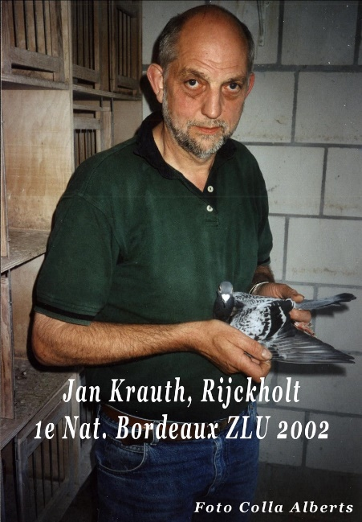
THE KRAUTH STRAIN
by Liam O Comain
The European strain of racing pigeons which this article is about, namely the Krauths, is one of the elite families of the sport. Obviously like most of my articles not a loft report per se but an insight into an outstanding family of thoroughbreds. Also this insight is of particular interest to me for as I look back over the decades I picture a small late-bred hen being timed at our family loft in Limavady, Co. Derry, on the day from Dinard in France. An evening of great joy for my late father and the rest of the family. In fact it took a racer of the Krauth blood to register my father's first return from France into the north west of Ireland.
This family of racing pigeons from the land of the tulip, namely Holland (the Netherlands), also retains a place in my thoughts because like the Stichelbauts, the Brackhuis and the van Bruaenes, the Krauths I associate with steel - steel of mind and body. A powerful breed to ensure the beating of the distances and the elements.
The Krauth strain was founded by Louis Krauth prior to his death in 1955. Louis had won scores of races prior to that year including 2nd Rome International and 1st Barcelona National. At the basis of the family were the Blondel strain. An interesting story from the history of the Krauths is that during World War 2 Louis, in order to prevent the occupying German army from taking his pigeons, selected about 30 birds and sent some of the latter to his mother-in-law while hiding the rest in an attic. Thus at the war's end he had some good breeders and racers while many other pigeoners were starting from scratch.
At this time some birds were purchased from Mons Pie Dinjens and Mons Dusarduyn which crossed well with the Wegge Blondels. When Louis died Martin Krauth continued racing and emulating the achievements of Louis. For example, during seven seasons of the 1960s, the loft registered in the national from Barcelona 1st, 13th, 52nd, 79th, 96th, 148th, 153rd, 202nd, 203rd, 299th, 351st and 433rd against the best of Holland. Plus in 1964 the birds scored 7th and 11th and in 1965 - 7th and 26th National from Marseille. With only two entries on both occasions.
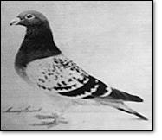
The distance from Barcelona was 746 miles and of course one cannot forget the immortal ' The Flying Dutchman' who as well as being 1st Orleans National (350 miles); twice 1st Chateauroux National (410 miles), also won the Barcelona National plus the Barcelona International. The latter pigeon was a powerful chequer cock - one of the best ever produced in Europe.
The Krauth pigeoners preferred inbreeding and if the weather was good their birds were paired up in February. For racing the method used was widowhood although for the longer marathon type races the natural method was preferred. For the latter races a hen feeding a three day old youngster usually was the candidate.
The main element of the feeding regime was Indian corn or maize plus peas, wheat, beans and green peas. A small amount of small seeds was provided and during the winter months approximately 20% of barley was added.
At club level in the village of Meersen the Krauths competed against about 140 members. And although their reputation was built upon distance racing, their pigeons produced winners at the short and middle contests. In fact another scribe once implied that their home was over run with trophies won at all distances.
As a strain it was one of the best produced in the 20th century and it will be noted in the history of the sport. That is as it should be for the strain that Louis and Martin Krauth founded and developed brought joy to the hearts of many pigeoners including that of a humble Irish pigeoner - my late beloved father.

